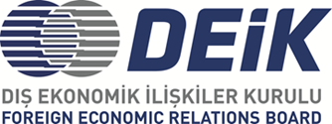

DEİK/ Türkiye – Bulgaria Business Council

**Meeting with the Minister of Innovation and Growth of the Republic of Bulgaria H.E. Milena Stoicheva**

**- Draft Programme-**

**24 November 2023, Friday**

**16:00 – 16:30 Registration**

**16:30 – 16:40 Opening Remarks**

* Mr. Zeki Sarıbekir, Chairperson, DEİK Türkiye – Bulgaria Business Council
* Mr. Nail Olpak, President, DEİK (tbc)

**Keynote Remark:** H.E. Milena Stoicheva, Minister of Innovation and Growth of the Republic of Bulgaria

**16:40 – 17:30 Trade and Investment Opportunities in Bulgaria**

* Ms. Mila Nenova, Executive Director, Invest Bulgaria Agency (IBA)
* Mr. Emrah Sazak, Vice Chairperson, DEİK Türkiye – Bulgaria Business Council & Director, BULTİŞAD

**17:30 – 17:45 Q & A**

* Participant companies will share their comments and ask their questions for an interactive discussion.

**17:45 – 18:15 Networking**