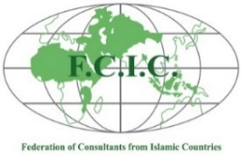

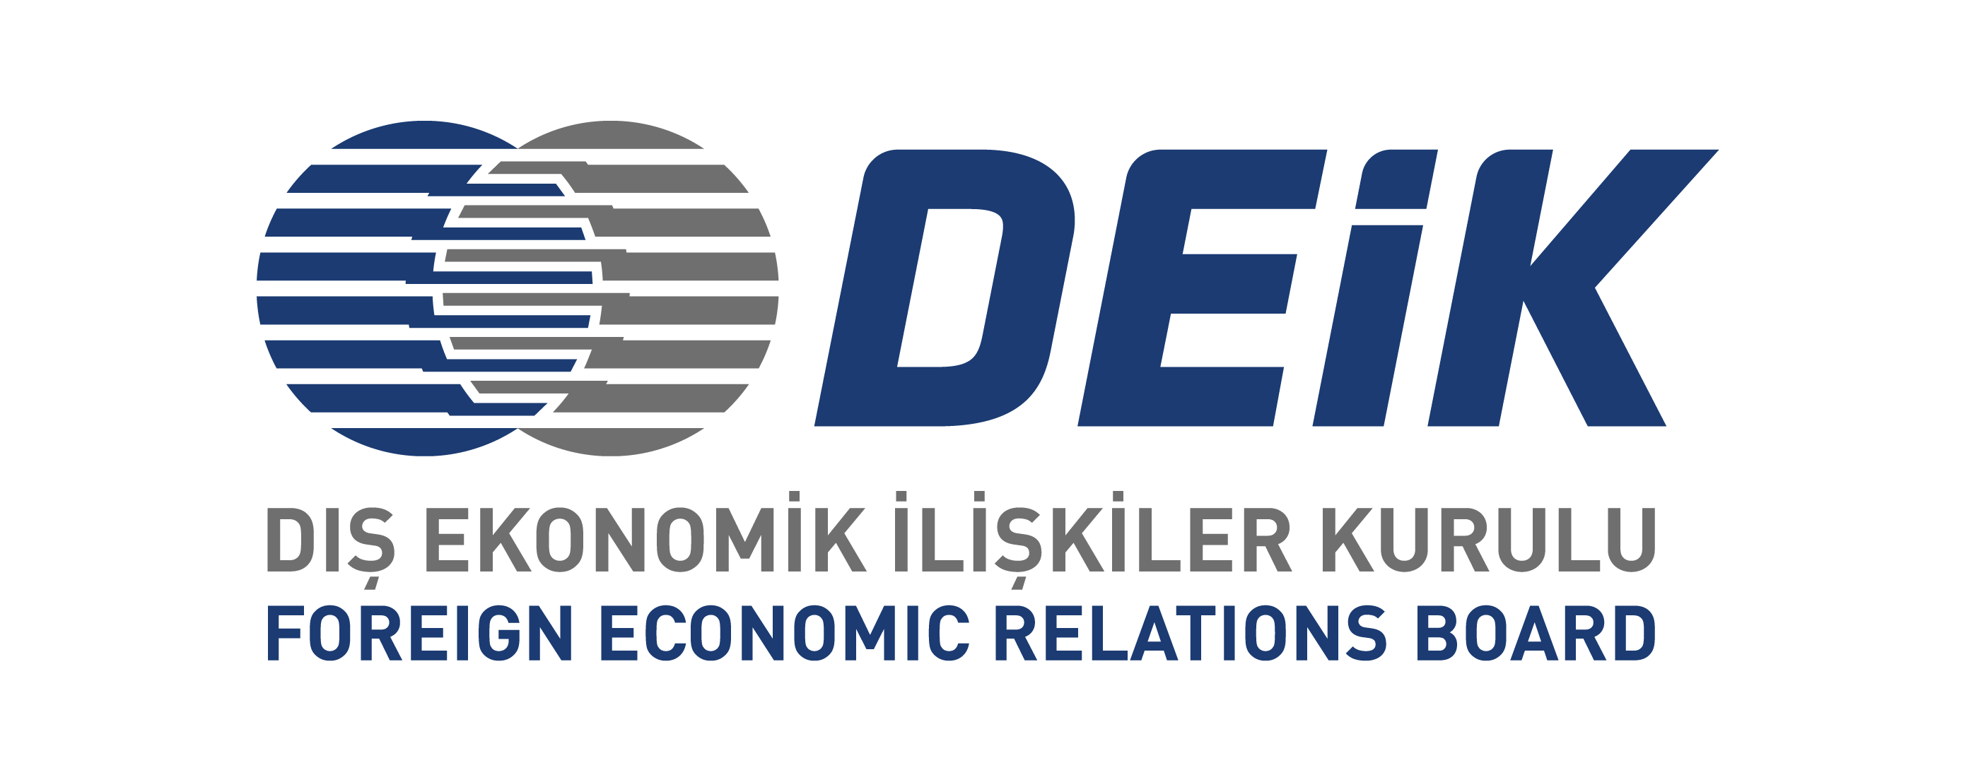

## FCIC-DEIK INTERNATIONAL ENGINEERING FORUM

## Reviving Communities: How the Technical Consulting (TC) Sector Drives Post-Natural Disasters Recovery

## 1 DECEMBER 2023

### DRAFT PROGRAM

### 1st December 2023, Friday

**09:30 – 10:15 Opening Statements** by;

**Mr. Mohamed E. Abdelrahman**, President of FCIC

**Mr. İrfan Aker,** President of Asso. of Turkish Consulting Engineers and Architects

**Mr. Munis Özer,** Chairman of Int. Technical Consulting Business Council-DEIK

**Mr. Elhadj Malick Soumare**, Acting Manager, Project Procurement Div.- IsDB **(tbd)**

**Mr. Murat Nesimoğlu,** Head of Department, Ministry of Trade

**10:15 – 10:45** **Mr. K. Gökhan Elgin**- Director of Istanbul Governorship Istanbul Project Coordination Unit (IPCU)- **Seismic Risk Mitigation & Emergency Preparedness Project**

**10:45-11:15 Coffee Break**

**11:15 – 12:45 Panel: Earthquakes and Recovery Planning**

**Moderator: Mr. Moncef Ziani**

* **Mr. Salih Buğra Erdurmuş-**WB Country Office: **Emergency Support and Urgent Recovery Plan Preparation**
* **Mr. Umut Akın-** Director of Structural Design and Transportation SuYapi Engineering Inc.**:** **Lessons Learned and Studies Conducted, Post Kahramanmaraş Earthquake(s) Experience in Turkey**

**12:45 – 14:00 Lunch Break**

**14:00 – 14:30 Mr. Abdul Aziz:** Vice President of FCIC- **The Role of Civil Engineers During Disaster Response and Recovery- Case Study Bangladesh**

**14:30 – 16:00** **Panel: Water Management (Flood Control-Drought Management)**

**Moderator: Mr. Mohamed E. Abdelrahman**

* **Mr. Nevzat Yaşar-**IsDB Country Office: **Project details for the Sindh Flood Emergency Housing Reconstruction Project in Pakistan**
* **Mr. Moncef Ziani- Vice President of FCIC: Flood and Drought Management Experiences in Northern Africa**

**16:00 – 16:45 Mr. Yüksel Tonguç**- Board Member of ATCEA & CEO of PROMER Consultancy and Engineering: **Wrap-up of the Forum**

**16:45 – 16:55 Closure by Mr. Mohamed E. Abdelrahman**

***Event will be conducted in English at the DEIK Premises (Seyrantepe-İstanbul)***